**HOW TO RUN LARAVEL PROJECT IN YOUR PC**

**1ST STEP**

**INSTALL COMPOSER**

**2ND STEP from laravel**

**INSTALL LARAVEL VIA COMPOSER official website**

**3RD STEP**

**CLONE FILE FROM GIT (when clone from git)**

**4TH STEP**

**UNZIP FILE**

**5TH STEP**

**INSTALL LOCAL SERVER (xampp,wamp or lamp )**

**6TH STEP**

**MOVE FILE IN EXTACTED FILE TO XAMMP WITHIN htdoc DIRECTORY**

**7TH STEP**

**GO TO LARAVEL PROJECT IN YOUR XAMPP THEN OPEN TERMINAL**

**8TH STEP**

**INSTALL COMPOSER WITHIN PROJECT**

**Command used: composer install**

**9TH STEP**

**UPDATE PROJECT DEPENDENT**

**Command used: composer update - -no – scripts**

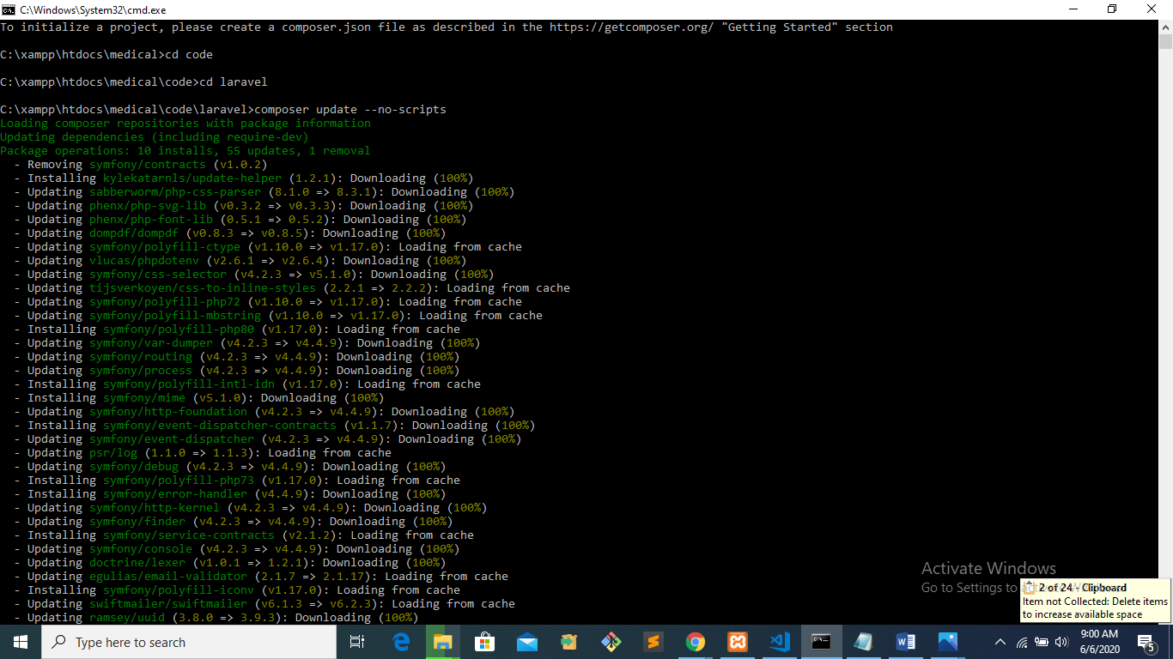

**NB: don’t do anything until completing installation**

**10TH STEP**

**REMOVE ALL AUTOLOAD FILES**

**Command used: composer dump-autoload**

**11TH STEP**

**UPADATE COMPOSER AGAIN**

**Command used: composer update**

**12TH STEP**

**CHANGE FILE TO .env.example .env**

**Command used: cp .env.example .env**

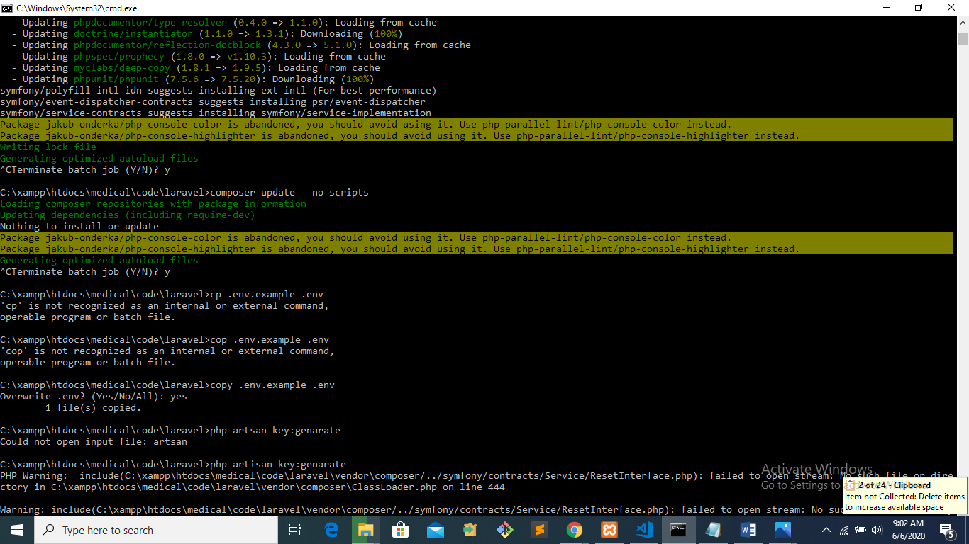

**13TH STEP**

**COPY NEW ENV FILE**

**Command used: copy .env.example .env**

**14TH STEP**

**GENERATE PHP KEY**

**Command used:php artisan key:generate**

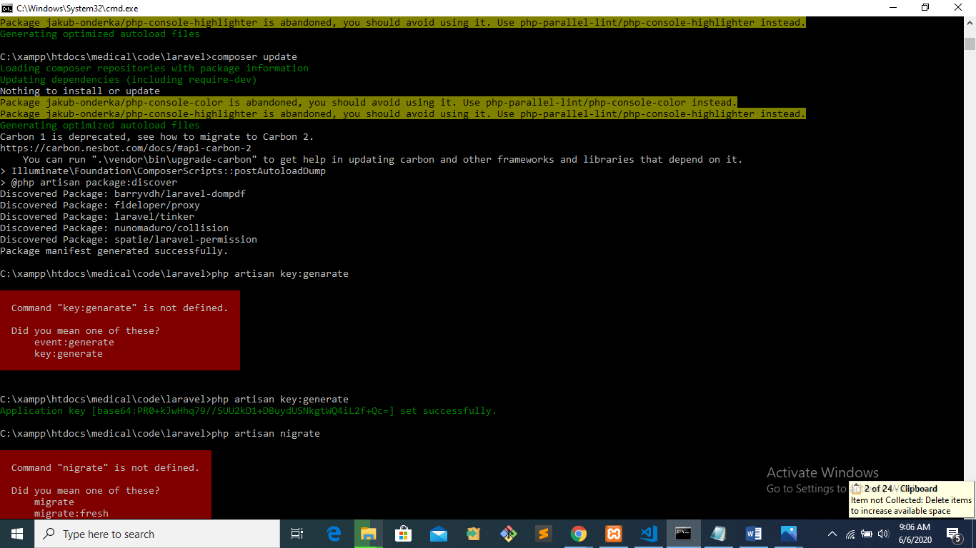

**15TH STEP**

**CREATE EMPTY DATABASE**

**Go to phpMyadmin**

**Create database**

**Enter databse name**

**16TH STEP**

**CHANGE THE INFORMATION ON .env FILE**

**DB_NAME: CREATED DATABASE ON 15TH STEP**

**DB_USERNAME: YOU’RE USER NAME IF IN WINDOW ROOT OR ‘DON’T WRITE ANYTHING’**

**DB_PASSWORD: DB MYSQL PASSWORD IN WINDOW ‘DON’T WRITE ANYTHING’**

**17TH STEP**

**MIGRATE YOUR DATA IN DB**

**Command used: php artisan migrate**

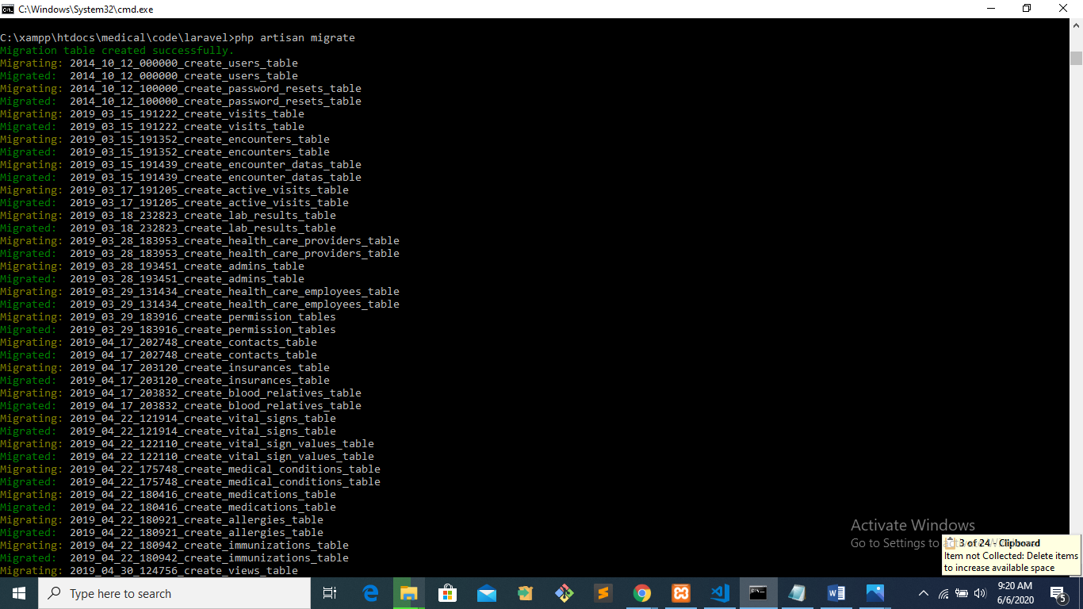

**18TH STEP**

**RUN YOUR LARAVEL PROJECT ON BROWSER**

**EXAMPLE**

